AWS ADVANCE ASSIGNMENT DAY 12 BATCH 1:
Question 1:
Task 1:
Create a dynamo db table with minimum two disaster recovery zones and verify
replication.
ss1: Disaster recovery regions with the table
Created disaster recovery region in Frankfurt and Sydney:
Screen shot for Sydney and the tables

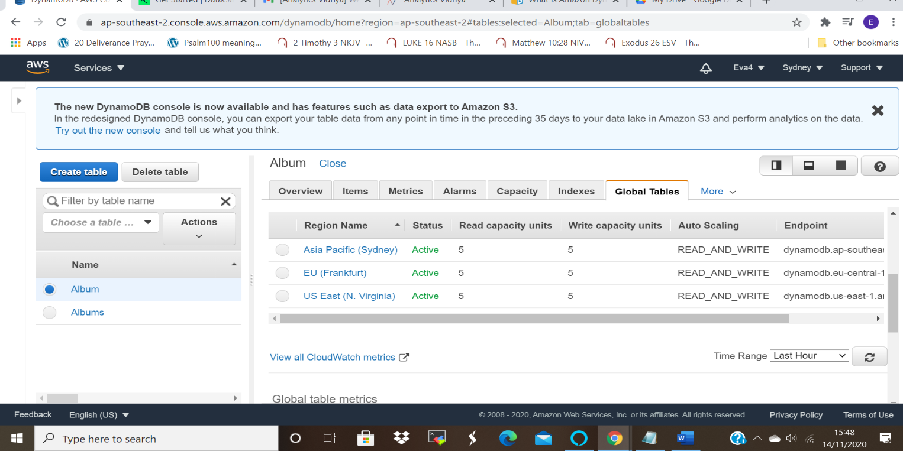

Ss for Frankfurt recovery Zone with the tables:
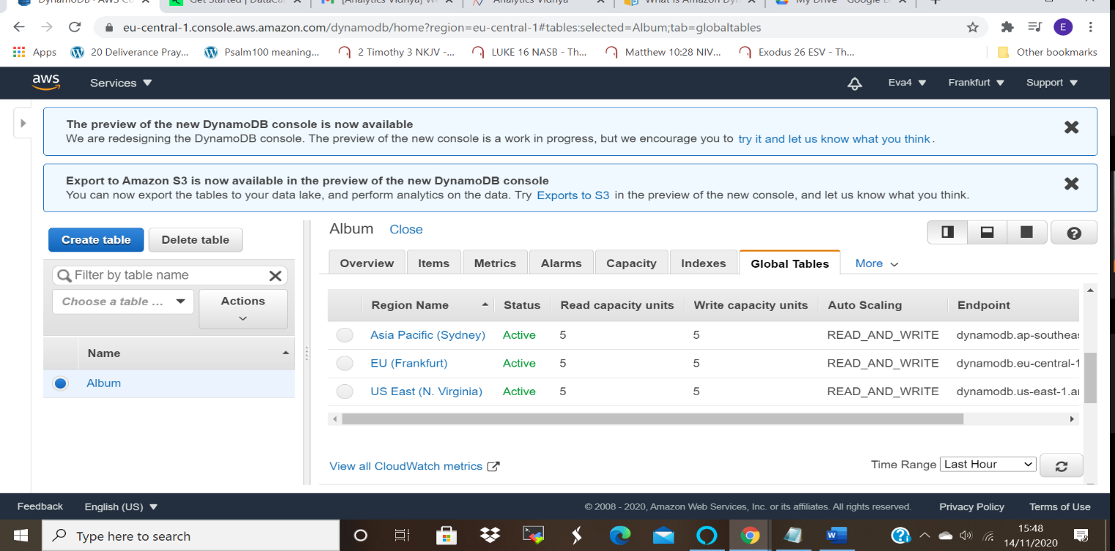

ss2: Home region with all items displayed
Home region is N.Virginia below is the screenshot and the items .
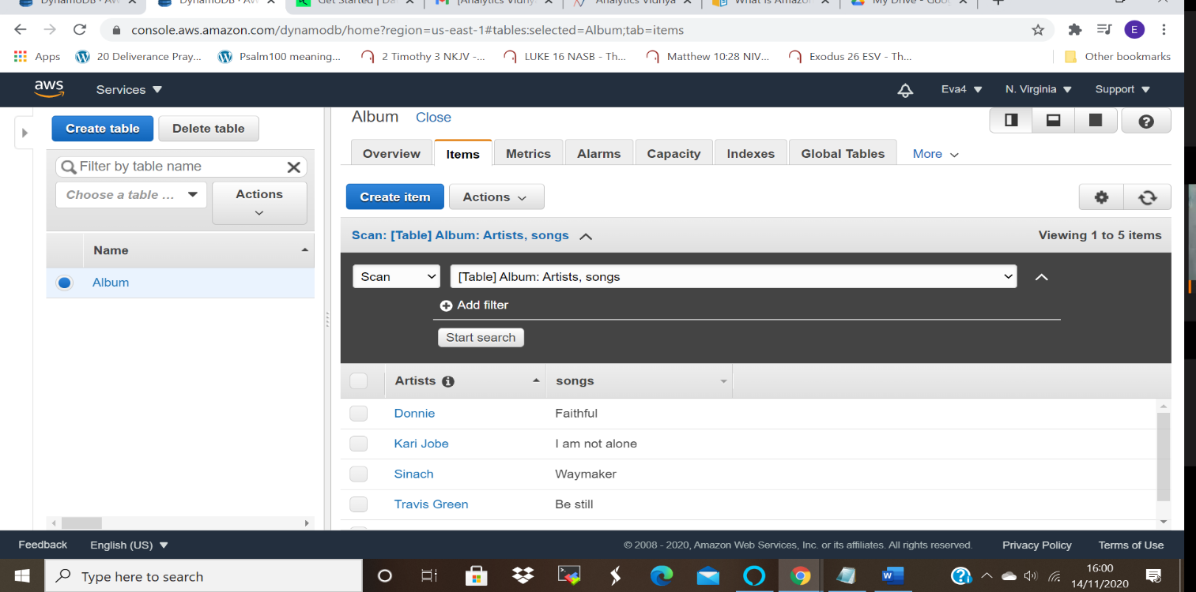

ss3: Use query to fetch few items
Used Partition key to fetch the items
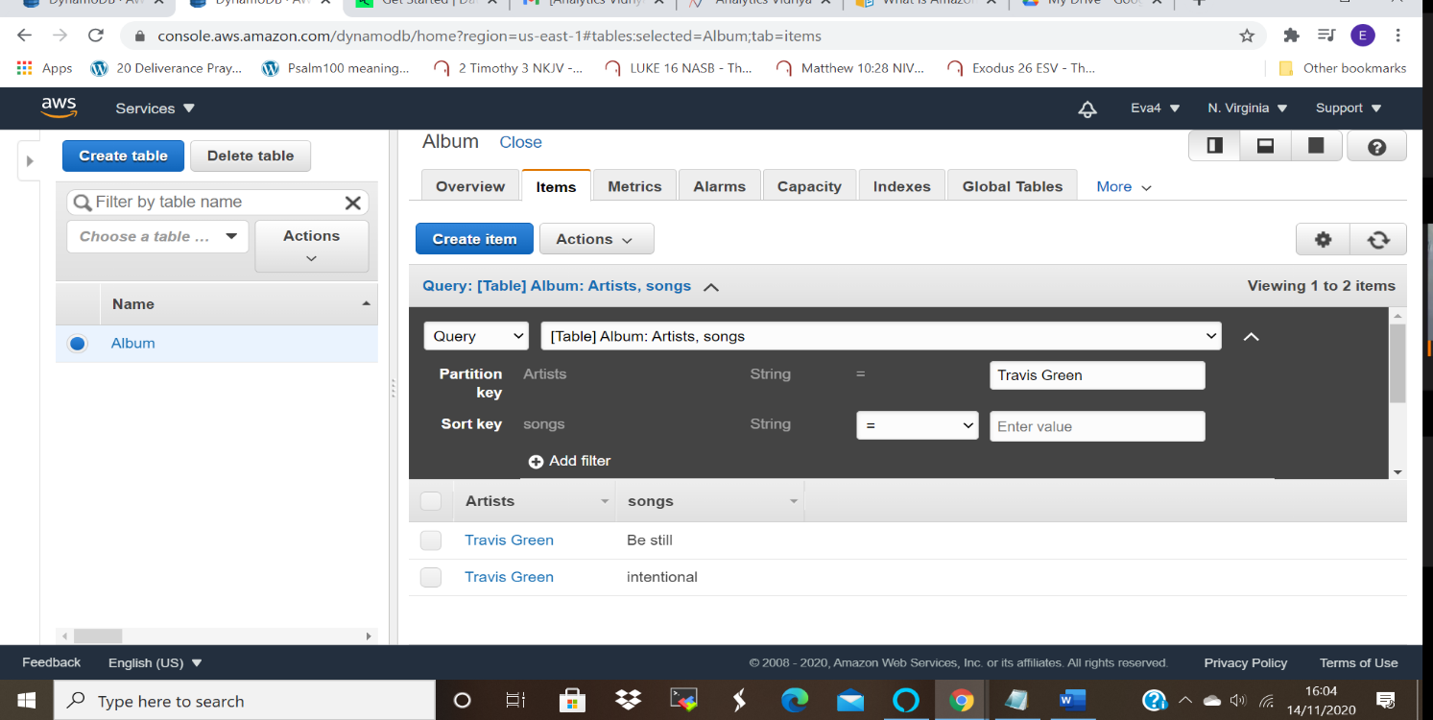

Used sort key to with partition key to fetch items:
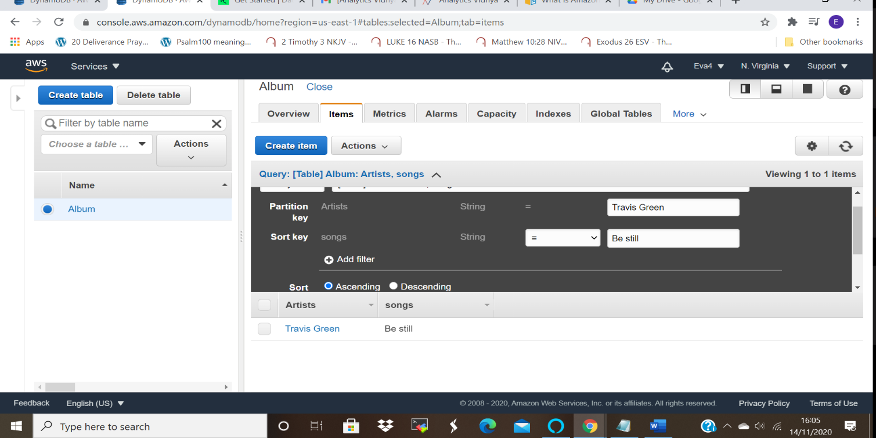

ss4: Deletion and verification:
when you delete you get a prompt of failure of deletion, and alerted that it takes place after 24 hours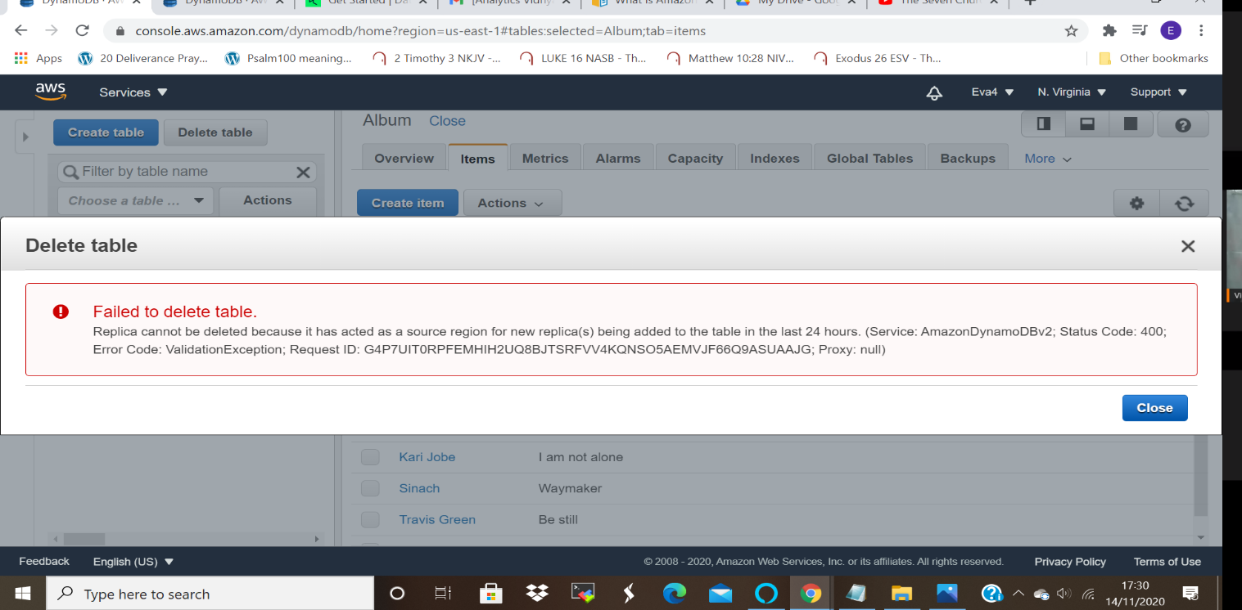
Deletion was only possible after 24 hours.

Task 2:
Creating a dynamo DB table with global secondary indexes and fetching data using global Secondary indexes.
ss1: Table with its items displayed
Below is the picture of MySockTable with the Items in it:
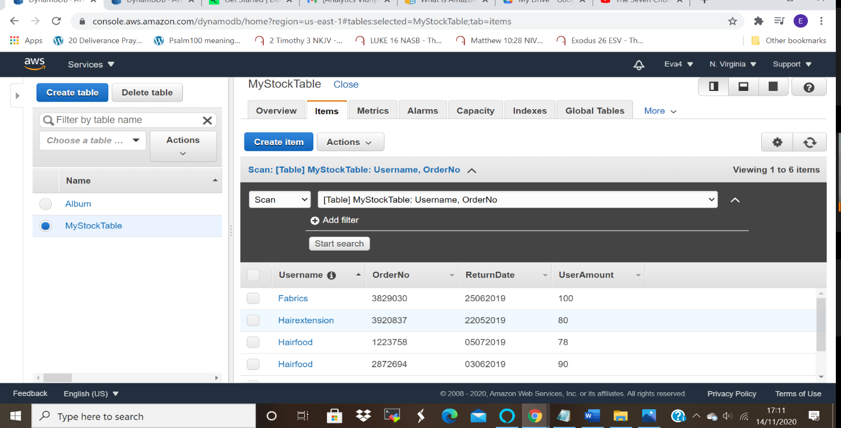

ss2: Creating global secondary index
Below is the screenshot for the created global secondary index
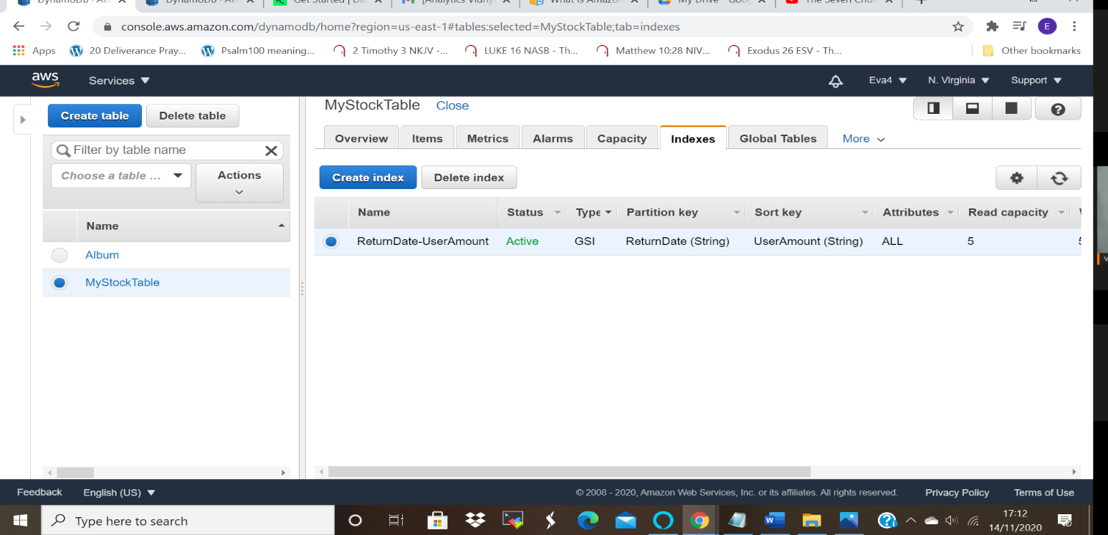

ss3: Scan with global secondary index
Item scanned using global secondary index -UserAmount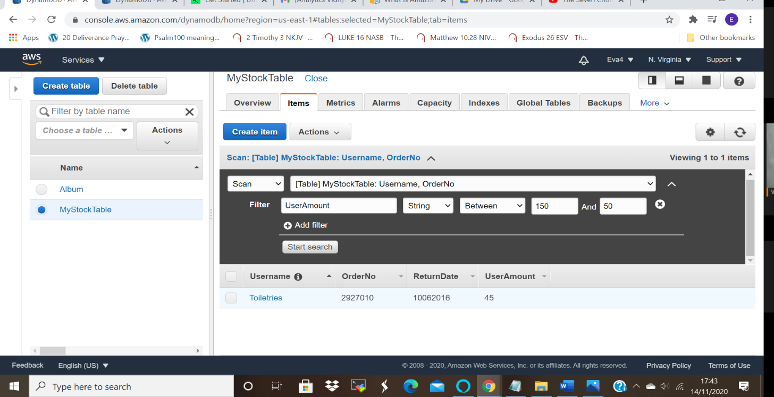

Screenshot of an item scanned using global secondary index-ReturnDate:
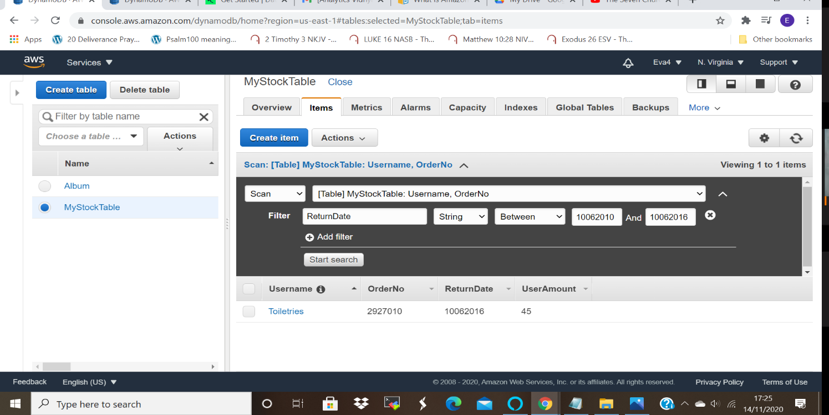

Scanned using username
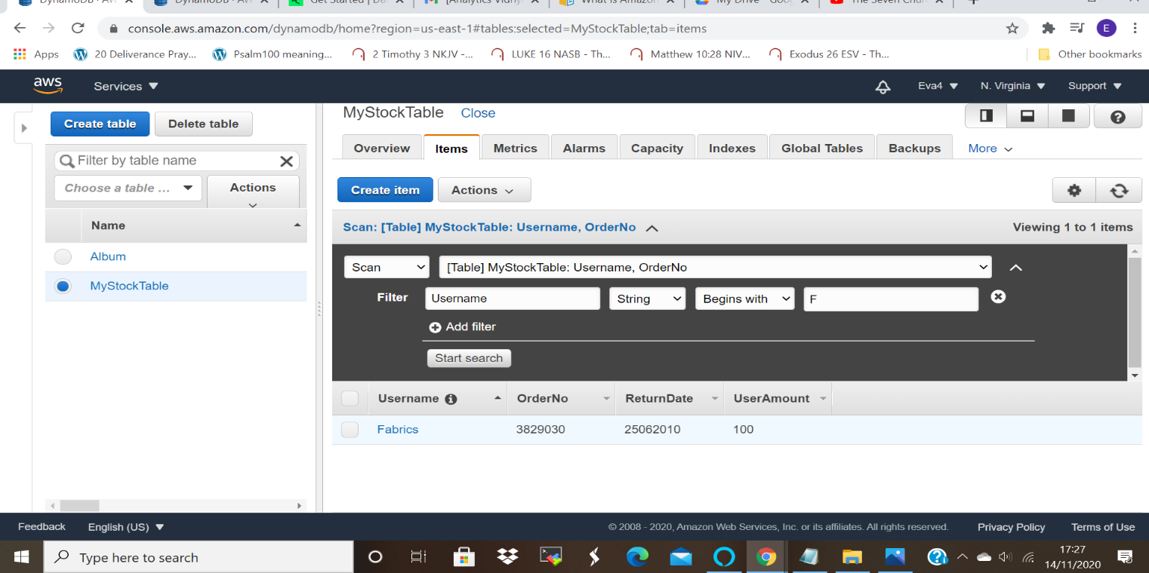

Task 3:
Deploying a python application in elastic beanstalk
ss1: Application page
Elastic beanstalk application is collection of EBS components, this includes environments, versions of applications and configurations of the environment.
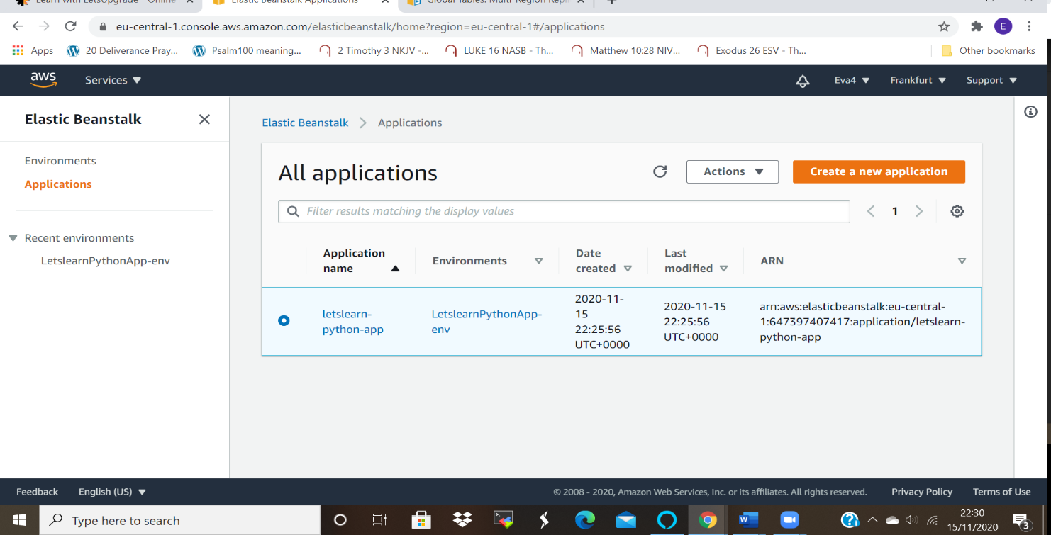

SS2: Environment list page:
Elastic beanstalk environment is a collection of AWS resources that enables applications versions to run.

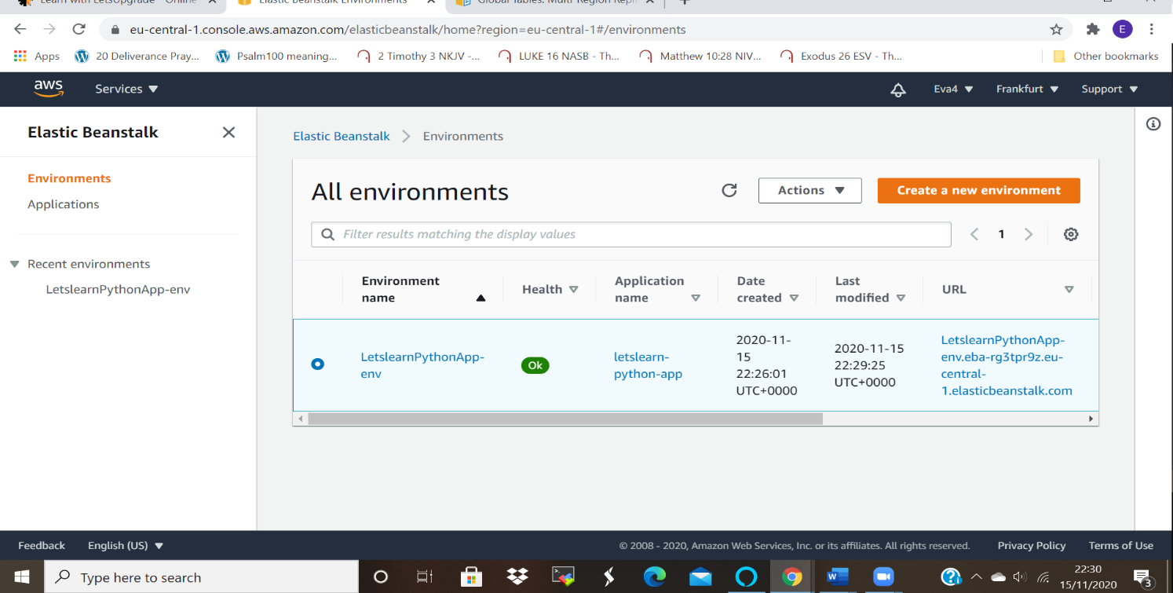

SS3: Environment health status page
When all the configurations are completed the health status of the environment turns to ok as shown in the diagram below:
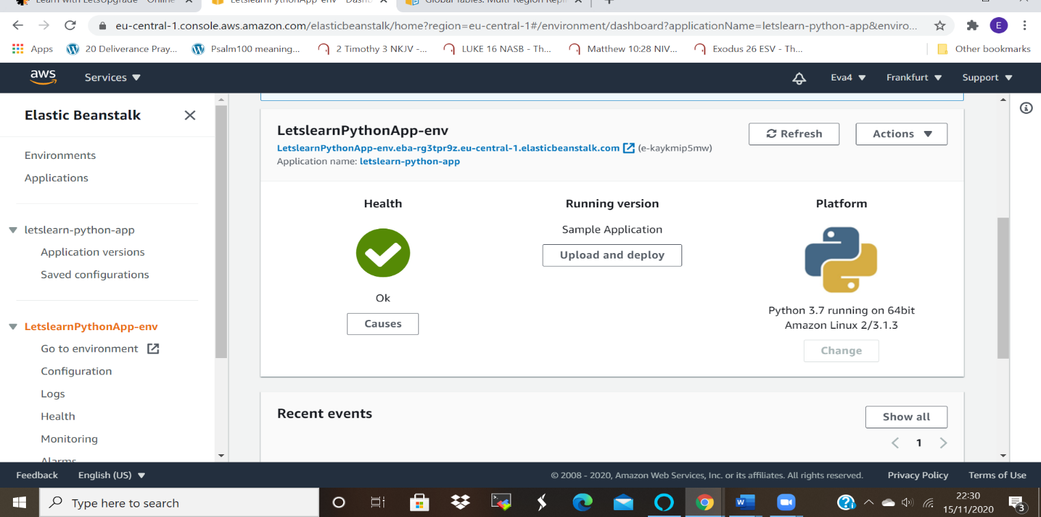

SS4: Web page launched using the elastic beanstalk environment.
The web page was launched after uploading the python file, and it enables access to the pages.

